524 J. Clyde Morris Boulevard
Newport News, Virginia 23601
Phone: (757) 534-7428
FAX: (757) 599-4897
Email: volunteer@thevlm.org

Office Use Only: Date Rec’d: ________________ Dir: __________

Adult Volunteer Application
I am (check one):
Adult Volunteer (ages 18 and above)

Family Volunteer: Please attach Junior Volunteer’s application(s) (ages 11-14 with parent) and submit together.

Name: Title (Circle One): Mr. Mrs. Miss Ms. Other:
Last First MI

Birthday (M/D/Y) Age:
Address: City: State: Zip:

Telephone: (H) (W) (Cell) Email:

Best time to reach you:

Emergency contact person: Relationship to you:

Phone: (H): (W): (Cell) Email:

WORK / SCHOOL BACKGROUND
Current Occupation OR Grade in School (if applicable): ___________________ Employer: _______________________
Supervisor: __________________________ Duties: ______________________________________________________
My employer offers: ______a Time-Off Program for Volunteers ______ A Donation Matching Program
Highest Academic Certificate/Degree Earned: ____________________ Date: ________ Major: ____________________
High School/College: _____________________________ Other degrees/certifications: ___________________________

TELL US MORE
What do you want to get out of your volunteer experience? ___________________________________________________________
__________________________________________________________________________________________________________

Are you required to serve a minimum number of volunteer hours for school or otherwise? Yes □ Number of Hours: No □
Do you speak a foreign language, or know Sign Language? Yes □ No □
If so; please specify: ___________________________________________________________________________________

What is your experience dealing and working with the public? ______________________________________________________________________________________________________________________________________________________________________________________________________________________

All positions within the museum require you to work cooperatively with small to large groups of people. Are you comfortable working in a group and around many people, in some cases guests to the museum? _______________________________________________
Please explain: ______________________________________________________________________________________________
___________________________________________________________________________________________________________

How did you learn about our volunteer program? Be Specific:__________________________________________________________

Being a volunteer may require flexibility. Are you interested in learning more than just your scheduled shift and location within the museum? ___________________________________________________________________________________________________

Skills and Interests: ___________________________________________________________________________________________

Previous volunteer experience: __________________________________________________________________________________

Do you have any health limitations that could affect your volunteer assignment? Yes □ No □
If yes; please explain: _________________________________________________________________________________
Are you a member of the Virginia Living Museum? Yes □ No □

Have you ever worked or volunteered at the Virginia Living Museum before? Yes □ No □
If yes; when and in what capacity? ________________________________________________________________________

As listed in the Position Description handout, please list the position(s) for which you would like to volunteer in the order of MOST interested. Please be specific.
(1) ______________________________ (2) ____________________________ (3) _____________________________

Regular Shifts may range from 9am -to 5pm daily. Animal Care is 9am -1pm only, and Horticulture is Tues, Wed, & Thurs AM only. Open Positions may be limited.

**Please mark your availability to volunteer at the Virginia Living Museum on the chart below:

 | Sunday | Monday | Tuesday | Wednesday | Thursday | Friday | Saturday
9:00 -11:00 am
11:00 - 1:00 pm
1:00 – 3:00 pm
3:00 – 5:00 pm

REFERENCES
Please provide us with names of two people whom you have, or recently had, a professional or business relationship. These would be people who have knowledge of your work performance (not neighbors, friends OR family).

Name: ______________________________ Title: __________________________ Telephone: ___________________
Email Address: ________________________________________

Name: ______________________________ Title: __________________________ Telephone: ___________________
Email Address: ________________________________________

PLEASE TAKE NOTE
We at the Virginia Living Museum place high priority on the safety of our volunteers. Please keep in mind that some volunteer positions involve contact with live animals. While the health of our animals is regularly monitored by veterinarians, contact with live animals may carry the possibility of exposure to animal-borne diseases.

APPLICANT CERTIFICATION
I certify that the above information is complete and true to the best of my knowledge and authorize the Virginia Living Museum to contact employers and references listed above concerning my work experience. I understand that the discovery of any misrepresentation or omission of the facts in this application may be cause for my immediate dismissal.
Signed: ____________________________________________________ Date: _________________________________

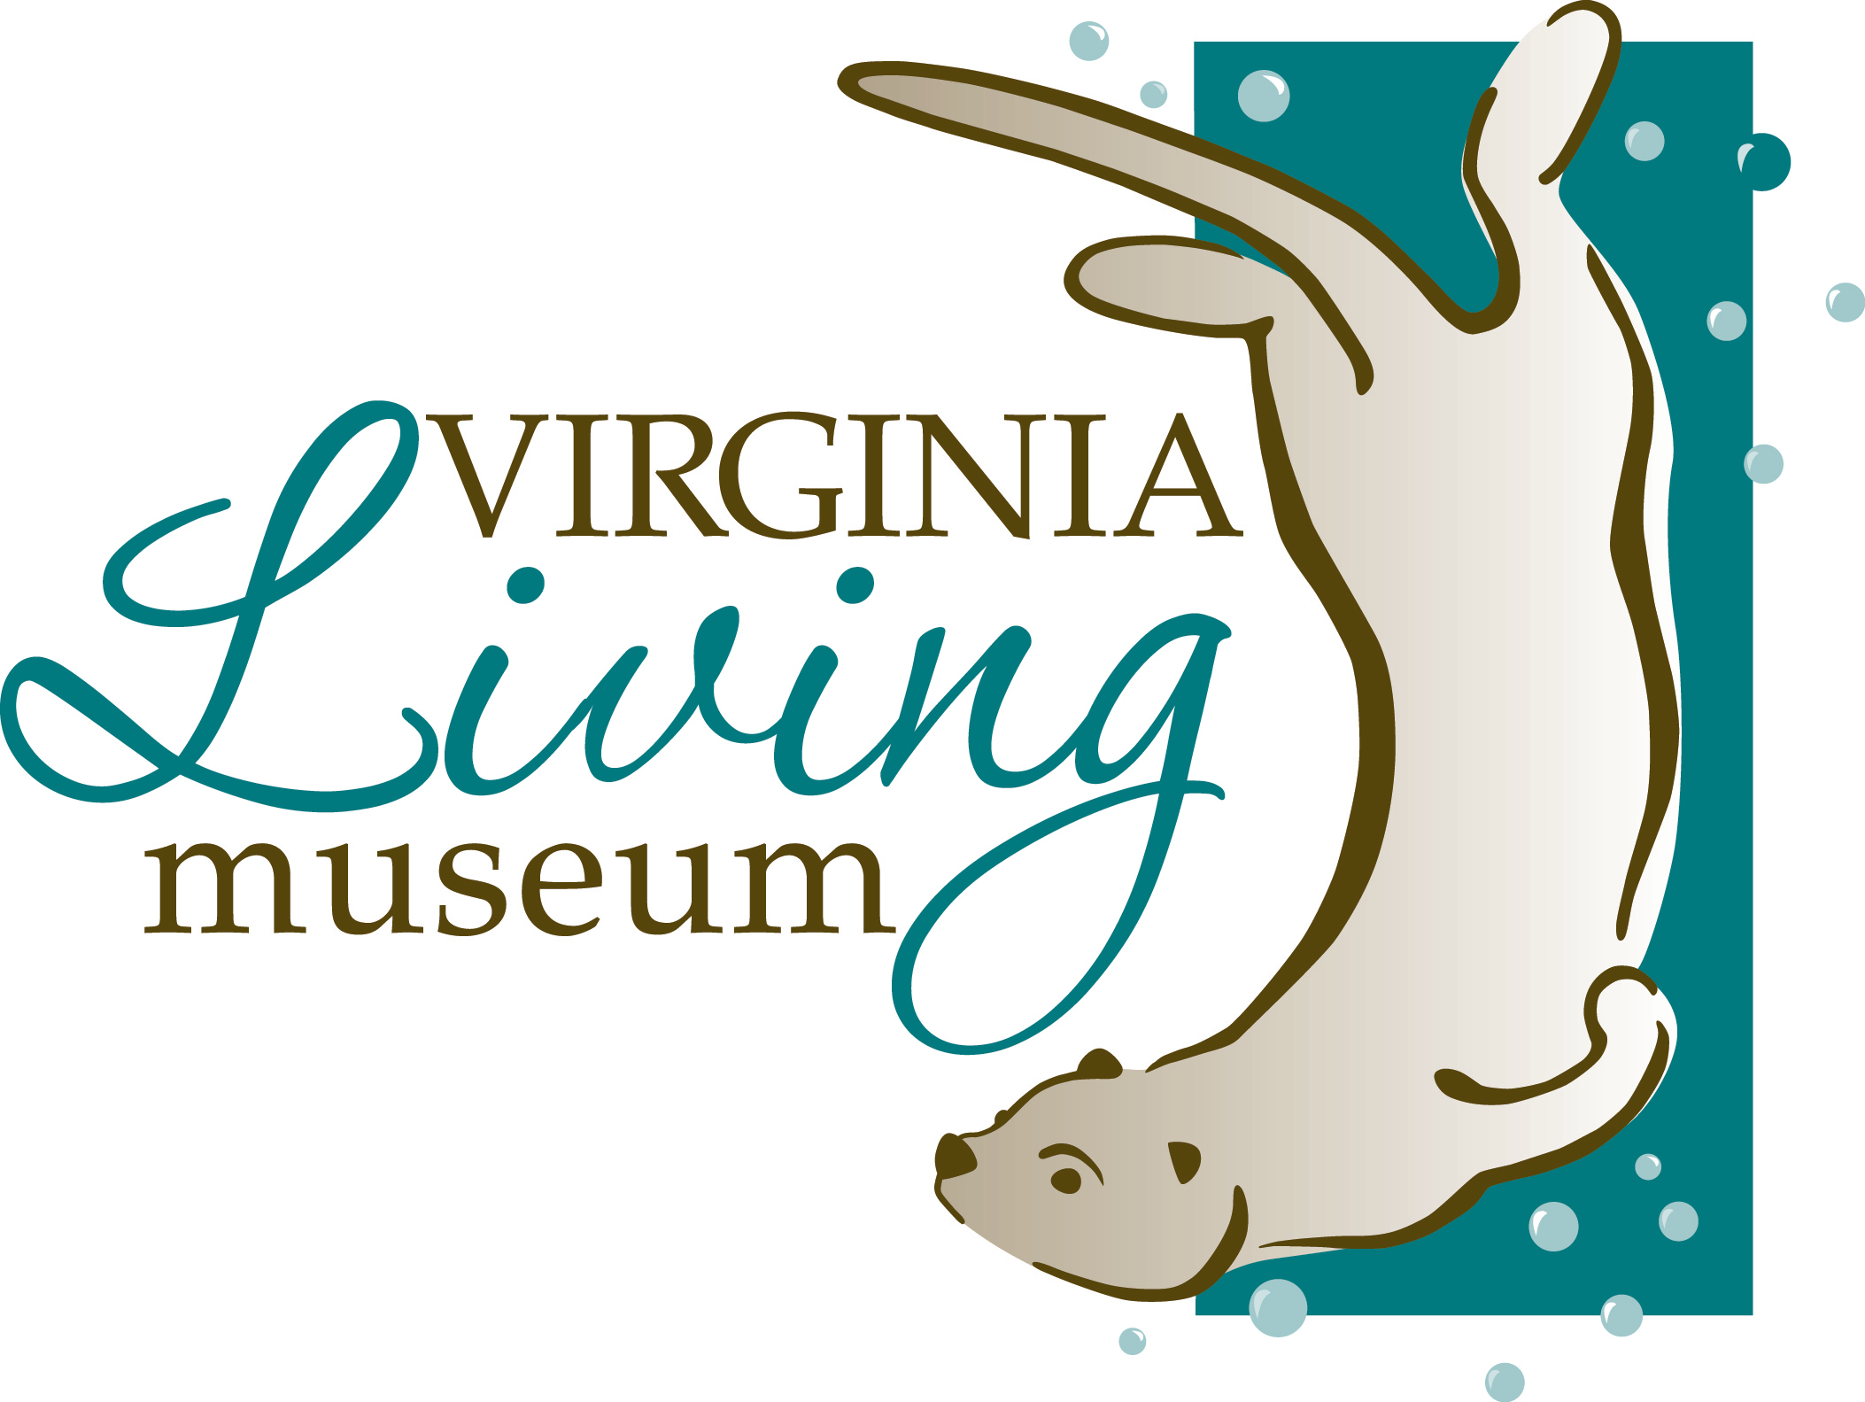
Volunteer Code of Conduct
Note: volunteers under 18 years of age need the signature of a parent or a guardian at the bottom of this form.

By signing this agreement, I, ______________________________________________, agree to the following:
(Please print volunteer’s name)

- I understand that the goal of volunteering is to engage and educate the public, and my attitudes and actions should always further that goal.

- I agree to work my entire volunteer shift as scheduled, to conduct myself in an appropriate manner, to be honest, to dress in attire that follows the volunteer dress code, to follow safety procedures, and to be prepared for my shift.

- I understand that if I cannot make a volunteer shift/training (or any part of a shift/training), it is important to notify the Volunteer Services Office ahead of time ( 24 – 48 hours notice) by calling (757) 534-7428, emailing volunteer@thevlm.org or signing out via the volunteer online portal.

- During my scheduled volunteer shift, I agree to follow directions given by staff, stay in my designated area, and though I may have friends who are also volunteers at the museum, I understand that while I am at the museum, my focus should be on the guests.

- I understand that I am responsible for reviewing all materials given to me at my interview, Orientation and trainings if accepted in to the program.

- I know that I represent the museum, and I promise not to engage in any activity that may cause harm to the animals, museum, others and/or me.

I understand that failing to observe the above pledges will result in disciplinary action and can result in my dismissal from the volunteer program.

________________________________________________ _________________________________
Volunteer Signature Date

________________________________________________ _________________________________
Parent/Guardian Signature of approval (if volunteer is under 18 years old) Parent/Guardian Phone Number
- I have read the above and give my child permission to volunteer.
Furthermore, I acknowledge my commitment and agree to provide
the support necessary to ensure his/her success.

