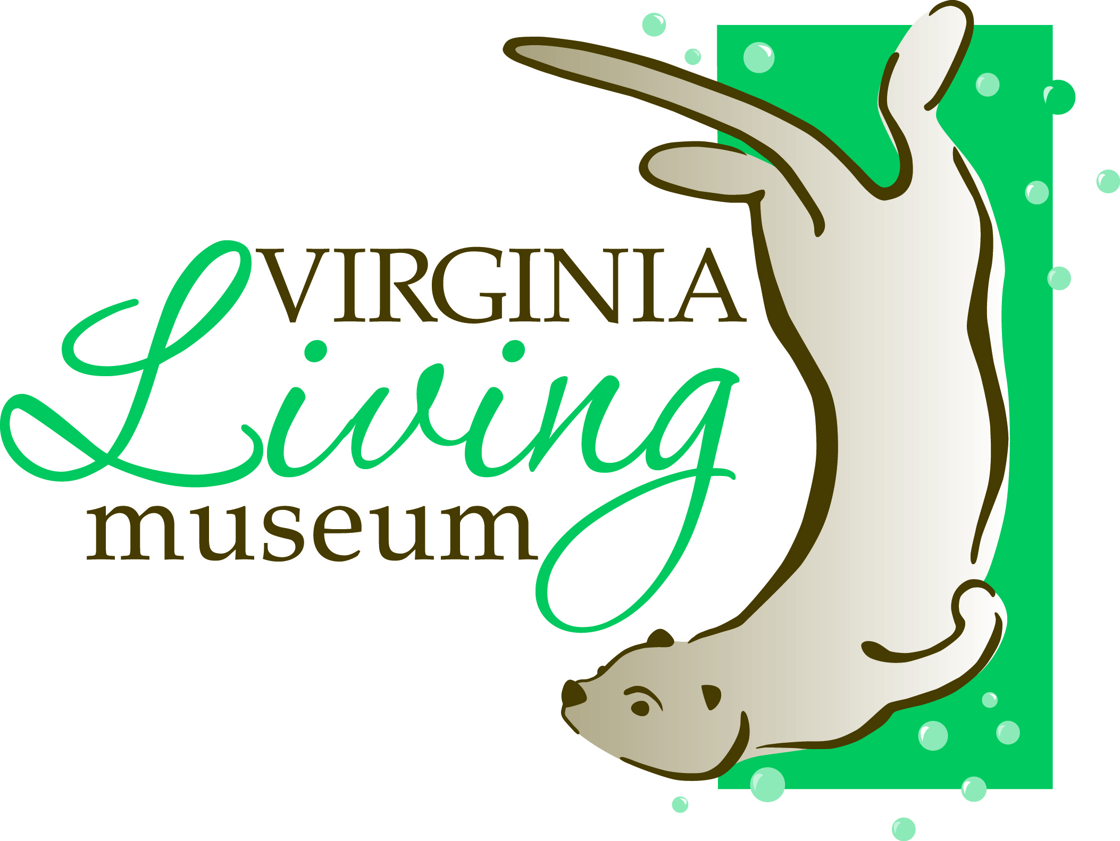
524 J. Clyde Morris Blvd.

Newport News, VA 23601

Phone: (757) 534-7428

E-mail: volunteer@thevlm.org

Office Use Only: Date Rec’d: __________________

Junior Volunteer Application (Ages 11-17)
I am (check one): _____Junior Volunteer (ages 15 - 17)
_____ Family Volunteer: Please attach Adult Volunteer’s application(s) (ages 11-14 with parent) and submit together.
Name: □ Miss □ Mr. Age: Birthday (M/D/Y): __________
Last First MI
Address: City: State: Zip:__________
Phone: (H): (Cell) : _________________________ Email:

Name of Parents/Guardians: ________________________________________________________________________
Emergency Contact: Circle one: Parent, Guardian, Other_______
Phone: (H) (W) (Cell) _______________ Email:

Do you have any health limitations that could affect your volunteer assignment? Yes □ No □ If yes; please explain:

School: Current Grade: __________________
Are you required to serve a minimum number of volunteer hours for school or otherwise? Yes □ Number of Hours: No □

Special Achievements/Awards: _____________________________________________________________________________________________

Extracurricular Activities/Interests/Hobbies: __________________________________________________________________________________

Previous paid/volunteer experience: _________________________________________________________________________________________

Any other experience dealing with the public: _________________________________________________________________________________

How did you learn about our volunteer program? Be Specific: ____________________________________________________________________

Why are you interested in being a volunteer? __________________________________________________________________________________

As listed in the Position Description handout, please list the position(s) for which you would like to volunteer;
in order of MOST interested. Please be specific.
(1) (2) (3) ________________________________

**Please mark you availability to volunteer at the Virginia Living Museum on the chart below:
 | Sunday | Monday | Tuesday | Wednesday | Thursday | Friday | Saturday
9:00 -11:00 am
11:00 - 1:00 pm
1:00 – 3:00 pm
3:00 – 5:00 pm

Parent/Guardian Permission
I have read my son/daughter ___________________________’s completed application and he/she has my permission and support to participate as a volunteer at the Virginia Living Museum.

Junior Applicant Signature: _________________________________________________________________ Date: _________________

Parent/Guardian Signature: ____________________________________________________ Date: _________________
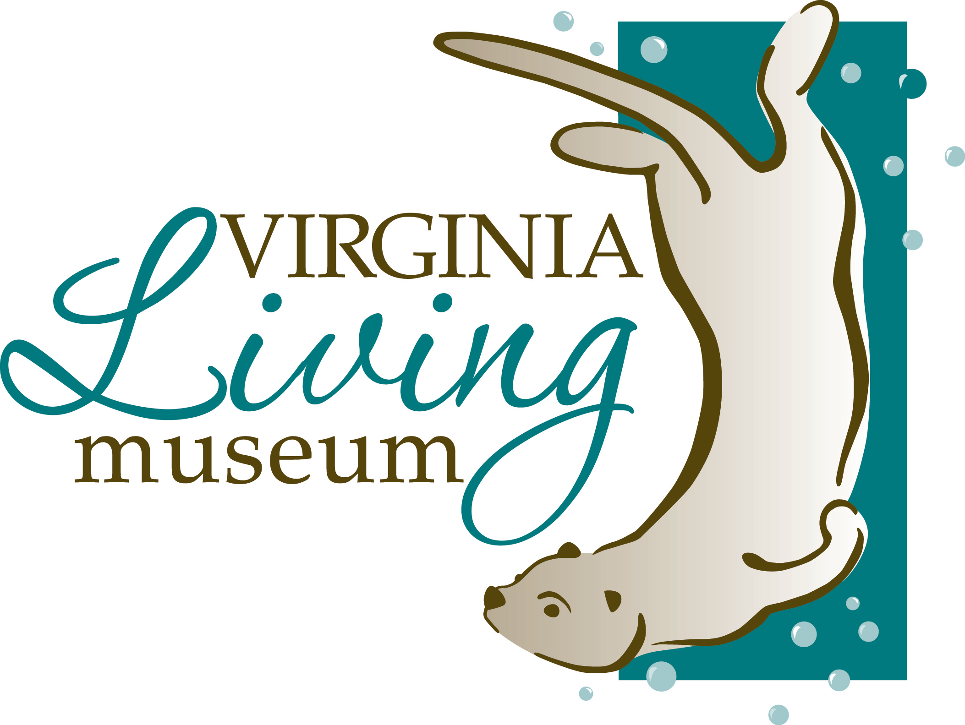

Volunteer Code of Conduct
Note: volunteers under 18 years of age need the signature of a parent or a guardian at the bottom of this form.

By signing this agreement, I, ______________________________________________, agree to the following:
(Please print volunteer’s name)

- I understand that the goal of volunteering is to engage and educate the public, and my attitudes and actions should always further that goal.

- I agree to work my entire volunteer shift as scheduled, to conduct myself in an appropriate manner, to be honest, to dress in attire that follows the volunteer dress code, to follow safety procedures, and to be prepared for my shift.

- I understand that if I cannot make a volunteer shift/training (or any part of a shift/training), it is important to notify the Volunteer Services Office ahead of time ( 24 – 48 hours notice) by calling (757)534-7428, emailing volunteer@thevlm.org or signing out via the volunteer online portal.

- During my scheduled volunteer shift, I agree to follow directions given by staff, stay in my designated area, and though I may have friends who are also volunteers at the museum, I understand that while I am at the museum, my focus should be on the guests.

- I understand that I am responsible for reviewing all materials given to me at my interview, Orientation and trainings if accepted in to the program.

- I know that I represent the museum, and I promise not to engage in any activity that may cause harm to the animals, museum, others and/or myself.

I understand that failing to observe the above protocols will result in disciplinary action and can result in my dismissal from the volunteer program.

________________________________________________ _________________________________
Volunteer Signature Date

________________________________________________ _________________________________
Parent/Guardian Signature of approval** (if volunteer is under 18 years old) Parent/Guardian Phone Number

**I have read the above and give my child permission to volunteer. Furthermore, I acknowledge my commitment and agree to provide the support necessary to ensure his/her success. I recognize that the VLM is not responsible for my child beyond the hours they are scheduled and that the VLM’s responsibility is limited to my child’s assigned tasks; further the museum reserves the right to send a JV home for not behaving according to our policies and procedures.

 
 

